GVPT 729a: In-class Exercise

1. Imagine you hypothesize that the probability of voting for the incumbent in a two-candidate race is higher for those who believe the economy is improving compared to those who think the economy is getting worse. Using the table of survey results below answer questions 1a and 1b.

Table 1. Voting for the Incumbent and Challenger by Views of the Economy (cell counts)

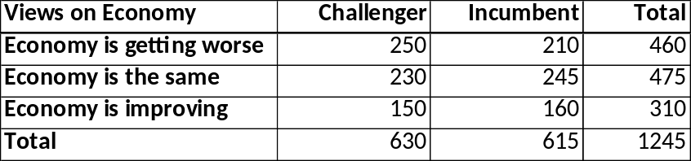

1a. What is the probability of voting for the incumbent?
49.3%

1b. In terms of the substantive results (ignore statistical significance), does the evidence support your hypothesis? Explain, using details, how you know (no more than 2 sentences). (5 points)
Improving: 51.6
Getting worse: 45.7

2. What is the OLS estimate of Y = α + ε?

αhat = Ybar

the intercept = the mean

3. Use the information below to answer the questions that follow.
Dependent variable: European Parliament Feeling Thermometer ranging from 0 (coldest) to
100 (warmest)
Independent variables: Female, coded 1 for female and 0 for male; education 1 for has a college degree or more and 0 for does not.
The following results were obtained from a survey of 1,500 citizens age 16 to 90 in European
Union member nations.

Table 2. OLS Estimate of European Feeling Thermometer Ratings by Sex
3a. Is the interpretation of the coefficient on the constant term in Table 2. useful on its own? If so, what does it represent? If not, why not?
Independent
Variables
Coefficient
p value
Constant
49
0.000
Female
-7
0.000

Yes, because it shows the average feelings for the parliament from men

3b. What is the substantive interpretation of the Female variable?

On average women will have a lower feeling thermometer score by 7 points than men on average

Table 3. OLS Estimate of European Feeling Thermometer Ratings by Sex and Education
Independent
Variables
Coefficient
p value
Constant
49
0.000
Female
Education
-7
3
0.000
0.045
3c. In Table 3, what would be a more useful way to label education?
College degree

3d. Is the interpretation of the coefficient on the constant term in Table 3. useful on its own? If so, what does it represent? If not, why not?

Yes, because it represents men with no college degree

3e. What is the substantive interpretation of the Female variable?

3f. Now imagine education is coded as:

1 = less than high school degree; 2 = high school degree; 3 = some college experience;
4 = college degree; 5 = graduate degree

Is the interpretation of the coefficient on the constant term in Table 3. useful on its own? If so, what does it represent? If not, why not?

No, because theres no zero for education

